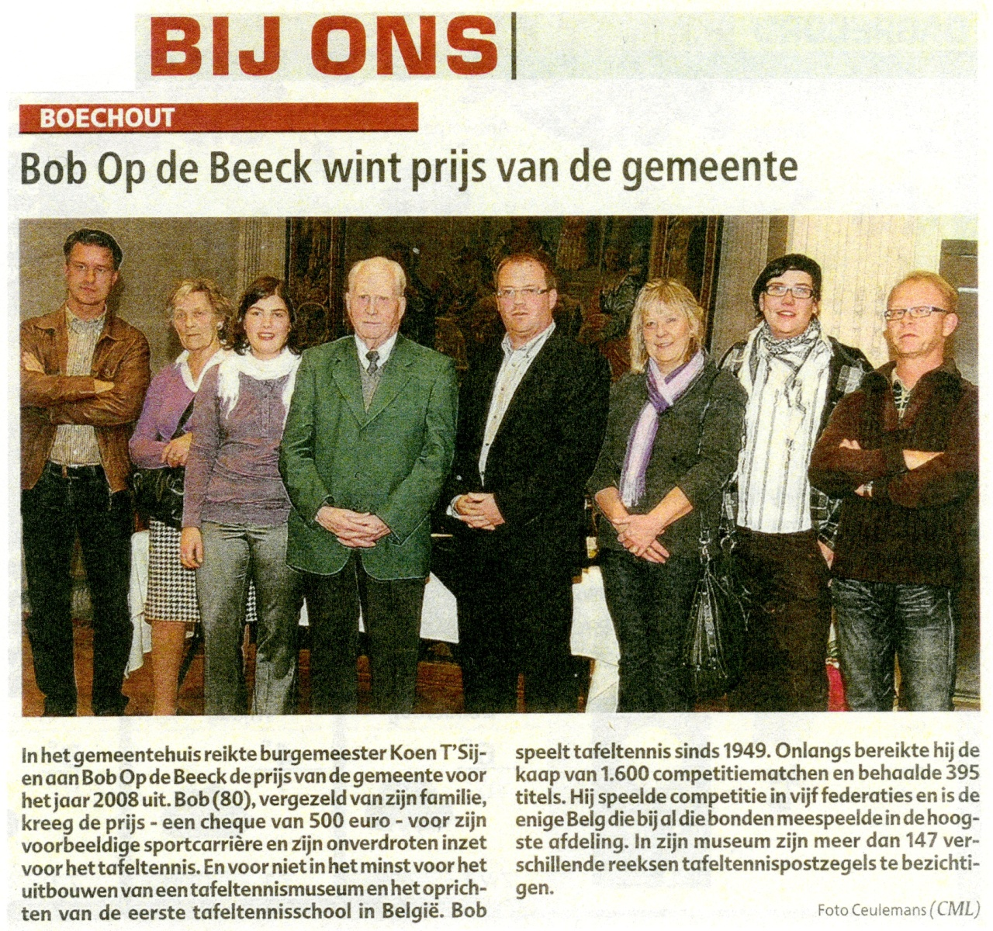

In the townhall of Boechout Bob Op de Beeck received the Award of the year 2008 from mayor Koen T'Sijen.  
Bob, aged 80, got this award — a check of 500 euro's —  accompanied by his family for his exemplary career as a sportsman, his everlasting dedication in promoting table-tennis and not in the least for a museum and the first school in Belgium for table-tennis.  
Bob plays table-tennis since 1949. Recently he played his 1.600th match in competition and he already won 395 trophies.  
As only belgian he played competition in the highest serie of the 5 existing federations.  
In his museum more than 147 series of table-tennsistamps are exposed.